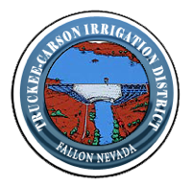
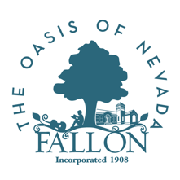
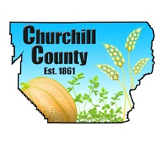

For Immediate Release
Media Contact:
Ty Whitaker, The Abbi Agency
ty@theabbiagency.com
775.722.3424

TCID, BOR, Churchill County and the City of Fallon collaborate on flood mitigation

FALLON, Nev. (March 16, 2017)— TCID, BOR, Churchill County, and the City of Fallon are collaborating on flood mitigation efforts and information, in an effort to provide the most current information to the public.

Lahontan Dam is an earth-filled embankment structure on the Carson River near Fallon. The Dam, completed in 1915, is in very good condition and may be expected to perform well during the upcoming spring runoff season or a seismic event.

On Tuesday, March 14, 2017, TCID shut down the right outlet valve at Lahontan Reservoir so that inspection of the outlet system and maintenance could be performed. It is expected repairs and maintenance will take 5 to 7 days. Bureau of Reclamation and TCID personnel began preparations with the shut down on Tuesday so that inspection can begin on Thursday morning; inspection should be completed the same day. Following the inspection and maintenance, flows will be reintroduced. Until this work is completed, flows in the Carson River below Lahontan may fluctuate.

For frequent updates, visit ChurchillCounty.org, or FallonNevada.gov.

###

